TOBB Economics and Technology University
in cooperation with
SNSPA Bucharest & St. Cyril and St. Methodius University of Veliko Tarnovo

ERASMUS Blended Intensive Program (BIP) Syllabus for 6 ECTS

MIS 501 Global Migration Studies: Governance, Law, Society, and Politics
by Prof Dr Deniz S. Sert denizsert@gmail.com & Prof Dr Haldun Yalçınkaya haldun@etu.edu.tr

Summer 2025
Online dates 30 June - 6 July 2025
In-person dates in Bodrum 21-25 July 2025
Paper & Video Submission date 15 August 2025

Objectives
International migration has become a defining feature of our globalized world, raising critical questions about mobility, governance, integration, and displacement. This course provides students with a comprehensive understanding of international migration by examining its historical roots, contemporary trends, and the complex political, economic, and social dynamics that shape migration flows. Key topics include migration theories, drivers of migration, the relationship between migration and globalization, the politics of migration governance, refugee and asylum policies, and the impact of migration on both sending and receiving societies. Special attention will be given to the intersection of migration with nationalism, gender, security, and development.
The course is at the Master's level yet undergraduate students with a GPA of 3.00 and above can take the course. All students must have sufficient English language level (B1).
The primary objective of this course is to equip students with the analytical tools and foundational knowledge necessary to understand international migration as a multifaceted phenomenon. By the end of the course, students will be able to:
- Analyze key migration theories and concepts.
- Understand the drivers and consequences of migration in different historical and political contexts.
- Assess the role of states, international organizations, and civil society in migration governance.
- Critically engage with policy debates on refugee protection, border control, and migrant integration.
- Develop independent research skills to explore migration-related topics.
Teaching Assistant
Ms. Gaye Solmaz e-mail: Gayesolmaz2018@gmail.com

Content
Courses: 21 hours online and 21 hours in person
ONLINE SESSIONS
Date | ZOOM Link  10:30-13:30 Istanbul Time Zone | Subject and Readings
30 June 2025 |  | Course Introduction & Migration Terminology  Deniz S. Sert & Haldun Yalçınkaya
Koser, K. (2007). International migration: A very short introduction. Oxford University Press, USA.

Video: Are we living in a time of unprecedented migration? https://youtu.be/kvxaONtyjJM
1 July 2025 |  | International Migration: Some History  Deniz S. Sert
Castles, S., De Haas, H., & Miller, M. J. (2014). The age of migration: International population movements in the modern world. Chapters 4 & 5.

Video: How Has Migration to Europe Changed Over Time? https://youtu.be/G3oqOaf91MA
2 July 2025 |  | Why do people move? Theories of Migration  Deniz S. Sert
Sert, D. S., & Erenler, T. C. (2020). “Theories of migration: reasons for mobility.” In No poverty (pp. 1061-1072). Cham: Springer International Publishing.
Video: How Much Does Global Inequality Drive Migration? https://youtu.be/VYxfeZmaYXM
3 July 2025 |  | Dilemma of the states: how to control migration?  Deniz S. Sert
Castles, S., De Haas, H., & Miller, M. J. (2014). The age of migration: International population movements in the modern world. Chapter 10.

Helbling, M., & Leblang, D. (2019). “Controlling immigration? How regulations affect migration flows.” European Journal of Political Research, 58(1), 248-269.

Video: Who Are We Allowing in? Who Are We Trying to Keep out? https://youtu.be/Fqb5HiKapf4
4 July 2025 |  | Migration & Diaspora  Itır Aladag Gorentas
Bauböck, R., & Faist, T. (2010). Diaspora and transnationalism: Concepts, theories and methods (p. 360). Amsterdam University Press.

Soysal, Y. N. (2000). Citizenship and identity: living in diasporas in post-war Europe? Ethnic and racial studies, 23(1), 1-15.

Soysal, Y. N. (2012). Post‐national Citizenship: Rights and Obligations of Individuality. The Wiley‐Blackwell Companion to Political Sociology, 383-393.

Bruneau, M. (2010). Diasporas, transnational spaces and communities. Diaspora and transnationalism: Concepts, theories and methods, 3(1), 35-50.
5 July 2025 |  | Global Migration Governance  Deniz S. Sert
Adamson, F. B. & Tsourapas, G. (2019). “Migration Diplomacy in World Politics.” International Studies Perspectives, 20, 113-128. https://doi.org/10.1093/isp/eky015

Pécoud, A. (2021). “Philosophies of migration governance in a globalizing world.” Globalizations, 18(1), 103-119. https://doi.org/10.1080/14747731.2020.1774316

Sert, D. Ş., & Türkmen, F. F. (2020). “Global policy on migration.” In Reduced Inequalities (pp. 1-11). Cham: Springer International Publishing.

Video: Want More or Less Migration? Here's What to Think About https://youtu.be/QhRrnvx6HBk
6 July 2025 |  | Migration in International Relations:  EU Pact on Migration and Asylum  Tsveta Markova
The EU Pact on Migration and Asylum, 2024. https://home-affairs.ec.europa.eu/policies/migration-and-asylum/pact-migration-and-asylum_en

Video: How Effective Are Borders in Keeping People out? https://youtu.be/SN-wHs49Qsg

IN-PERSON SESSIONS
Date | In-Person | Subject and Readings
21 July 2025 | In-person | Meeting and Introduction  Türkiye & international migration  Deniz S. Sert & Haldun Yalçınkaya
Yıldız, U., & Sert, D. (2023). “The transformation of migration governance in Turkey.” In Turkey’s Challenges and Transformation: Politics and Society on the Centennial of the Republic (pp. 145-164). Cham: Springer International Publishing.
22 July 2025 | In-person | Forced migration: wars, disasters, and climate  Deniz S. Sert & Haldun Yalçınkaya
Fransen, S., & De Haas, H. (2022).” Trends and patterns of global refugee migration.” Population and Development Review, 48(1), 97-128.

Mitchell, S. M., & Pizzi, E. (2021). “Natural disasters, forced migration, and conflict: The importance of government policy responses.” International Studies Review, 23(3), 580-604.

Video: Will Climate Change Lead to More Migration? https://youtu.be/uTE-FX44v-8
23 July 2025 | In-person | Migration and Development  Deniz S. Sert & Haldun Yalçınkaya
De Haas, H. (2020). “Paradoxes of migration and development.” In Routledge handbook of migration and development (pp. 17-31). Routledge.
24 July 2025  Thursday | In-person | Wrap up and discussion on the current issues in international migration –preparation to find topics for final papers  Deniz S. Sert, Tsveta Markova, Birgül Demirtaş
Students are expected to come up with at least five academic articles on their topics!
25 July 2025 | In-person | Gender and Migration  Birgül Demirtaş
Daniel, B. & Gordon, M. (2015). “Enhancing Women Migrant Workers’ Rights and Mainstreaming Gender in Global Migration Governance,” Centre for International Governance Innovation, Policy Brief.

Donato, K. M. et al. (2006). “A Glass Half Full? Gender in Migration Studies,” International Migration Review, Spring, Vol. 40, No. 1, pp. 3-26.

Girard, L. (2017). Migration in the 2030 Agenda, IOM, Geneva.

Sert, D., & Turkmen, F. F. (2022). Gender, mobility, and displacement: From the shadows to questioning binaries. In Oxford Research Encyclopedia of International Studies.

Assessment

Attendance | 15%
Participation/Quizzes/Group Work | 25%
Research Paper and Video Presentation | 50%

Students will receive 6 ECTS credits only if they fulfill requirements of in-person attendance and submission of all assignments. Students who fail to fulfill ECTS requirements will be given a signed certificate of attendance.

Final Papers
Once enrolled to the course, students should choose a unique topic pertaining to international migration that will be approved by the course lecturer. Word limit for the final paper is 1500 words (-250, +500). A 100-word abstract and a bibliography are required. You should cite at least 10 academic sources in the paper and add them to the bibliography, at least two sources should be from the required readings on the syllabus.
All written assignments will be uploaded to Turn-It-In programme to ensure academic integrity.
Academic writing rules must be followed strictly. Please follow the guidelines of the Journal of International Relations for academic writing and referencing.
The link to the guidelines: https://www.ir-journal.com/for-authors/guidelines

Presentation Videos
Students are also required to submit around 10-minute video recording of themselves whilst presenting their final papers. The submission date of the final paper and the presentation videos will be no later than August 15th, 2025. More information on the presentation format will be provided during the course.

Submission of the papers and video recordings
Please send research papers and video recordings to the teaching assistant Ms. Solmaz before the deadline. Your file names should read as: Surname_Name_Title

!!! Plagiarism
Plagiarism will not be tolerated under any circumstances. Any text, idea, data, or argument derived from another author’s work must be explicitly identified as a quotation, accompanied by a precise citation of its source. Failure to do so constitutes academic misconduct and will incur the most severe penalties available under university regulations. The use of ChatGPT, other generative–AI tools, or any form of automated composition software is strictly prohibited. Should you be uncertain about what constitutes plagiarism or require clarification on citation practices, you must consult the course lecturer without delay. Remember that your original writing is not only expected but essential; you are fully responsible for the integrity and authenticity of every sentence you submit.
o4-mini

--- BODRUM DAILY PROGRAM ---
20 July 2025 – SUNDAY Location: Serpina Hotel
ALL DAY | Arrivals and check-in to Serpina Hotel
21 July 2025 – MONDAY
10.00-10.50 | Meeting and Introduction  Türkiye & international migration  Deniz S. Sert & Haldun Yalçınkaya
11.00-11.50
12.00-12.50
13.00 | Transfer to Serpina Hotel
14.30-17.00 | Visit to Bodrum museum of Underwater Archaeology
22 July 2025 – TUESDAY
10.00-10.50 | Forced migration: wars, disasters, and climate  Deniz S. Sert & Haldun Yalçınkaya
11.00-11.50
12.00-12.50
13.00 | Transfer to Serpina Hotel
23 July 2025 – WEDNESDAY
10.00-10.50 | When does migration end?  Deniz S. Sert & Haldun Yalçınkaya
11.00-11.50 | When does migration end?  Deniz S. Sert & Haldun Yalçınkaya
12.00-12.50 | When does migration end?  Deniz S. Sert & Haldun Yalçınkaya
13.00 | Transfer to Serpina Hotel
24 July 2025 – THURSDAY
10.00-10.50 | Wrap up and discussion on the current issues in international migration -preparation to find topics for final papers  Deniz S. Sert, Tsveta Markova, Birgül Demirtaş
11.00-11.50
12.00-12.50
13.00 | Transfer to Serpina Hotel
19.00-21.00 | GALA Cocktail at Serpina Hotel Lobby Cafe
25 July 2025 – FRIDAY
10.00-10.50 | Gender and Migration  Birgül Demirtaş
11.00-11.50 | Gender and Migration  Birgül Demirtaş
12.00-12.50 | Gender and Migration  Birgül Demirtaş
13.00 | Transfer to Serpina Hotel

LECTURERS (in order of appearance)

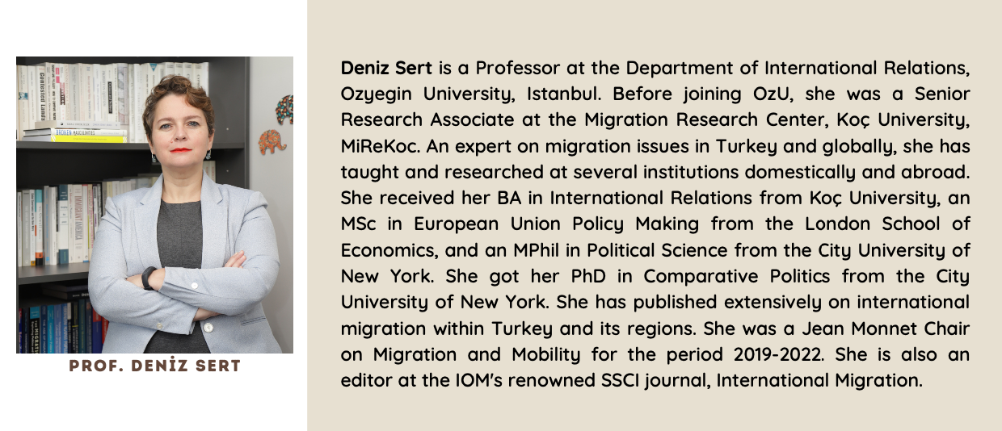

Tsveta Todorova Markova is a distinguished legal scholar and security expert based in Sofia, Bulgaria. Since 2017 she has led the Department of National Security at the Faculty of Philosophy, Veliko Tarnovo University “St. Cyril and Methodius,” and holds an Honorary Associate Professorship in Geography, Regional Development and Tourism at Bishop Konstantin Preslavsky University. Previously, she served two consecutive five-year terms (2002–2012; 2007–2012) as Chairman of Bulgaria’s State Commission for Information Security, representing the Republic in NATO and EU Security Councils and overseeing classified-information policy and legislative initiatives. A Doctor of Science in “Unregulated Trafficking in Human Beings” and ISO 27001 lead auditor, she combines judicial experience as a former district appellate judge with extensive project leadership in national and European security research.

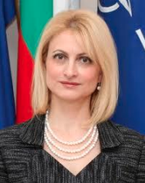
ASSOC. PROF. TSVETA T. MARKOVA

Itır Aladağ Görentaş is an associate professor at Kocaeli University/ Turkey. The researcher holds a PhD from Istanbul University with the dissertation “Foreign Public Law before National Courts in Terms of International Law”. She specialises in migration law, migration- citizenship nexus and access to fundamental human rights. She has papers and articles on topics related to international law, human rights law and migration law and delivered invited talks in several European universities on especially migration vs. citizenship and refugee crisis. Between October 15, 2022 and October 14, 2023, the researcher conducted her post- doctoral research project on conditionality of Germany’s Turkish origin female citizens in accessing fundamental human rights at Philipps- Universitat Marburg Center for Near and Middle Eastern Studies. Also in 2019, she studied at Leipzig University Faculty of Law as a visiting scholar, a beneficiary of Leibniz Invitations Program, with her project on Muslim migrants’ fundamental human rights generally. Currently, her research focuses on differentiated naturalisation regimes, categorisation of migration and their effects on inclusion and fundamental human rights.


Assoc. Prof. Itır Aladağ Görentaş

